**Population Shifts – May 2018**

The current world population, according to [www.census.gov/popclock/world](http://www.census.gov/popclock/world) : 7,468,138,529 (continually growing…)

The US population: 327,579,476

Continental populations and growth rates: ([www.worldometers.info/world-population/population-by-region/](http://www.worldometers.info/world-population/population-by-region/))

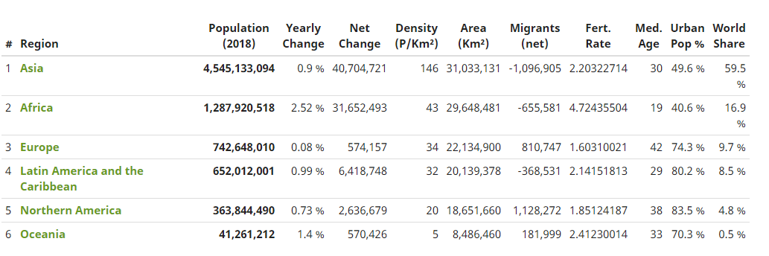

**Natural disasters:**

Hurricanes

* Asia: see PowerPoint presentation with data.
* North America: 1.75 hurricanes per year, 0.60 major hurricane per year (major is hurricane on steroids; faster wind speeds, and therefore more damage.)
* From 1851 – 2015, US coastline was hit with 290 hurricanes and 97 major hurricanes.

<http://www.aoml.noaa.gov/hrd/tcfaq/E19.html>

<https://www.depts.ttu.edu/nwi/research/DebrisImpact/Reports/DDS.pdf> average of 17 deaths per hurricane for the US.

<https://www.iii.org/fact-statistic/facts-statistics-hurricanes> cross-reference here, average from 1997 to 2016 is 25 deaths from hurricanes annually, ranging from 0 – 1518 deaths (random number generator)

Tornadoes: around 1000 happen annually, resulting in an average of 80 deaths

Thunderstorms: 157 deaths per year, about 100,000 thunderstorms annually (US)

*** The rest of the data is in the PowerPoint file called “Rates of Population Change.pptx”. ***

*Each PP table cell holds two values: rate of occurrence and the average deaths. This is annual information.

LINKS (The links contain information that is used):

<https://www.statista.com/statistics/269648/number-of-earthquakes-by-country/>

<https://www.statista.com/statistics/236725/earthquakes-with-the-most-fatalities-in-the-us/>

<https://www.volcanodiscovery.com/volcanology/faq/how-many-eruptions-per-year.html>

<https://nypost.com/2017/10/12/volcanoes-kill-540-people-per-year-study/>

<https://www.usgs.gov/faqs/how-many-deaths-result-landslides-each-year>

<http://wilcfry.com/stats.htm>

<https://afsp.org/about-suicide/suicide-statistics/>

<https://www.transformationstreatment.center/resources/overdose/many-people-die-drugs-year/>

<https://www.preventionweb.net/english/countries/statistics/index_region.php?rid=3>

<http://www.bom.gov.au/cyclone/faq/>

<https://en.wikipedia.org/wiki/2016%E2%80%9317_Australian_region_cyclone_season>

<http://www.abc.net.au/science/articles/2010/06/04/2918660.htm>

<https://www.earthquaketrack.com/v/safrica/recent>

<https://www.preventionweb.net/english/countries/statistics/index_region.php?rid=1>

<http://floodlist.com/africa>

<https://www.escape.com.au/world/lightning-strikes-worlds-biggest-hot-spots/news-story/882b4a0971a960b701fe77e09bec9a2c>

<https://en.wikipedia.org/wiki/List_of_South_America_hurricanes>

<http://www.islandnet.com/~see/weather/storm/tornadoes-samerica.htm>

<https://en.wikipedia.org/wiki/Tornado_climatology#Common_misconceptions>

<https://www.earthquaketrack.com/v/southamerica/recent>

<https://www.vaisala.com/sites/default/files/documents/11.Zhang,%20Meng,%20Ma.pdf>

<https://www.researchgate.net/publication/267855823_Annual_rates_of_lightning_fatalities_by_country>

<https://www.nytimes.com/2017/06/23/world/asia/china-sichuan-landslide.html>

<https://en.wikipedia.org/wiki/List_of_continents_by_population>

<https://en.wikipedia.org/wiki/List_of_tornadoes_and_tornado_outbreaks_in_Asia>